Overview  Country or Region: United States  Industry: Retail  Customer Profile  Accruent is the leading provider of solutions to optimize the performance of real estate locations—stores, restaurants, banks, and corporate offices—by driving revenue growth and reducing costs.  Business Situation  Accruent serves leading retail chains, as well as global enterprises, that need to manage complex real estate portfolios with information frequently divided among different departments and databases.  Solution  Accruent—by using Windows Vista™, Microsoft® Virtual Earth™, and the 2007 Microsoft Office release—created powerful, Web-based visualization tools for real estate site selection, analysis, and management.  Benefits  - Powerful visualizations now easy to create  - User interface development dramatically improved  - Intelligent collaboration enabled |  |  | “The new tools we get with Windows Vista … give us a really fluid 3-D analysis of the market information. Our customers get insights and views they’ve never had before.”  Bart Waldeck, Director of Product Marketing, Accruent
 |  |  | Accruent specializes in real estate performance solutions that allow retail companies to manage the entire lifecycle: market planning, site selection, project management, lease administration, and facilities management. Accruent recently updated its Store Lifecycle Management (SLM) solution in just seven months. Developers combined Microsoft® Virtual Earth™ maps with demographic data by using the Windows® Presentation Foundation features of Microsoft .NET Framework 3.0, formerly known as WinFX®, managed-code programming model to provide Accruent customers with exciting visualization tools to analyze store locations, predict store performance, and maximize store revenue while reducing store development and occupancy costs. With the powers of Windows Vista™ and the 2007 Microsoft Office system, Accruent’s SLM software suite is easier to use and more powerful than ever before.
 |  |  | 

Situation
Accruent was founded in 1995 to offer software solutions to retail and corporate real estate managers. In 2004, the company acquired two other leading lease administration companies and licensed a complimentary software package covering the other applications that make up Store Lifecycle Management (SLM). Today, Accruent offers an end-to-end solution for complete lifecycle management of retail stores, from market planning to site selection, project management, lease administration, and facilities management.
Fast Facts
Number of developers | 4
Weeks to complete | 24
Developer tools | Microsoft Visual Studio 2005 Team Edition for Software Developers  Visual Studio 2005 Tools for the Microsoft Office system  Microsoft Virtual Earth SDK  ASP.NET 2.0
Programming language | Microsoft Visual C#
Programming model | - Microsoft .NET Framework 2.0 with Web parts  - Microsoft .NET Framework 3.0 (formerly WinFX )  - Windows Communication Foundation “Indigo”  - Windows Presentation Foundation “Avalon"  - XML Paper Specification (XPS)  - ASP.NET, codename “Atlas,” Community Technology Preview (CTP)

Brick–and–mortar stores are the foundation of the retail industry and provide the bulk of the industry’s revenue. The cost of leasing and managing store locations is second only to salaries and benefits as an expense item.

Many large companies with hundreds or even thousands of stores manage these valuable and expensive assets in separate departments—real estate, design, construction, lease administration, and facilities management—with separate databases that frequently don’t connect with each other or even share data very easily.

To remedy this situation, Accruent, a Microsoft® Gold Certified Partner, updated its portfolio of products devoted to retail store lifecycle management. Using Microsoft Virtual Earth™, the Microsoft Windows Vista™ operating system, with the .NET Framework 3.0 (formerly known as WinFX®) managed-code programming model for Windows®, and the 2007 Microsoft Office release, the new suite of Accruent products brings together the entire range of business processes related to retail store management.

Solution
Accruent’s resulting suite of products covers all aspects of retail space management, including developing market strategy, choosing store locations, designing and constructing the store, administering leases, and managing store facilities after construction has been finished.

In just seven months, Accruent created a version of its Web-based product suite designed to take advantage of the new Windows Vista operating system and the integration within the 2007 Microsoft Office release. The new Accruent version includes elements of all five major real estate functions and allows store development organizations to do things they’ve never been able to do before.

Creating Fluid 3-D Analysis Tools
The updated product suite converges the tasks of retail store development into cross-departmental business processes, breaking down functional silos and consolidating disparate data sources into the company’s single Location-Centric Data Model. Retailers can now analyze real estate performance in real-time and dramatically impact revenue, cost, and compliance drives.

Data Visualization
Accruent developers relied on the .NET Framework 3.0 programming model, Windows® Presentation Foundation technology, Microsoft Virtual Earth, and Microsoft Visual Studio® Team Edition to quickly build data visualization applications that meet the needs of Accruent customers. In addition, tools like ASP.NET 2.0, codenamed “Atlas,” made it possible to easily take advantage of AJAX (Asynchronous JavaScript XML) techniques on the Web and enabled Accruent to create ASP.NET pages with a rich, responsive user interface (UI) and server communication (see Figure 1).

Windows Presentation Foundation provides a display engine and a single runtime to quickly and easily take advantage of the graphics capability of modern computers. Windows Presentation Foundation also makes it possible for developers and designers to work together to create data displays that go far beyond previous applications. Accruent developers created the site selection and market-planning modules in a way that takes advantage of both sophisticated mapping functions and the ability of Windows Vista to create powerful, effective data visualization from raw data.
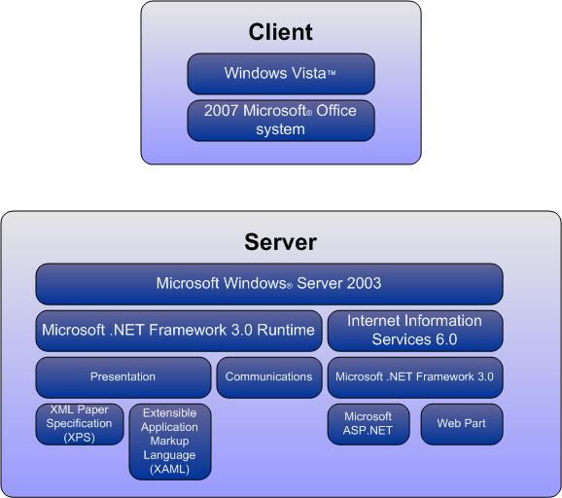
Figure 1. Accruent solution is built on Windows Vista™, the .Microsoft® NET Framework 3.0, and XML.
Accruent uses the Microsoft Virtual Earth mapping software development kit (SDK) and demographic data from Microsoft MapPoint® 2006 to provide customers with a graphical view of their market data. “The new tools we get with Windows Vista—the graphical tools and user interface tools that are built into [Windows] Vista—give us a really fluid 3-D analysis of the market information. Our customers get insights and views they’ve never had before,” explains Bart Waldeck, Director of Product Marketing at Accruent.

Figure 2 illustrates how aerial views from Virtual Earth can be used to map market data.

The market planning and site-selection modules give companies a map of their proposed market areas, with the demographic data overlaid on top of aerial photos. Figure 3 shows the demographic data displayed as colored blocks.

Integration with 2007 Microsoft Office Release
In addition to the visualization tools, developers were able to more tightly integrate features with the full range of 2007 Microsoft Office system products. Built around XML and a set of new extensibility technologies, the 2007 Microsoft Office system gives developers the ability to quickly build collaboration and enterprise content management to business intelligence and project management.

“By opening up the 2007 Microsoft Office system to being really XML-based, we can embed parts of our application into parts of [Microsoft] Word, anywhere we want, and vice versa,” says Waldeck.
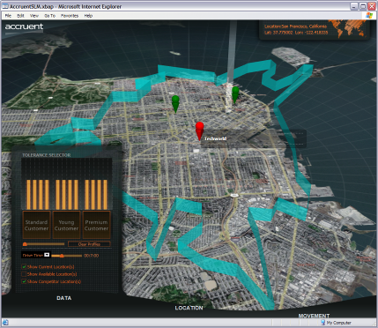
Figure 2. Map data from Microsoft Virtual Earth™ defines the trade area for a store location.

Accruent developers created a custom task pane and custom “ribbon” with tabs to reveal line-of-business (LOB) data that can be pulled into personal productivity programs, such as Microsoft Office Word, as shown in Figure 4. In addition, developers were able to build, by using Microsoft Office SharePoint® Portal Server 2007, a dashboard that links lease documents in Word with LOB information about store performance, competitor’s stores, and other potential locations or sites. SharePoint 2007 made it easy to create tools that allow Accruent customers to collaborate across the enterprise or even with outside contractors or brokers.
Benefits
By building with Windows Vista and the 2007 Microsoft Office system, Accruent can cost-effectively increase revenue by providing its customers with high-end tools that seamlessly integrate with familiar productivity programs.

“What [Windows] Vista and the 2007 Microsoft Office release offers us is the ability to bring together all these functions into a single interface. We can take these separate functions and use them across business processes, not just in departmental silos,” says Bart Waldeck, Director of Product Marketing for Accruent.
Powerful Visualizations Now Easy to Create
The Accruent team easily created amazing customer data views that simply were not previously available, thanks to Windows Vista and the 2007 Microsoft Office system. The Accruent developers knew that customers need access to a broad range of data. Using the new Windows Presentation Foundation visualization tools and maps from Virtual Earth, the Accruent solution lets customers view and analyze their business data in a location context, which dramatically improves their understanding and enhances their ability to make critical business decisions.
Figure 3. Demographic data can be displayed visually for rapid analysis.
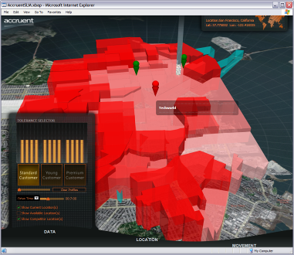
Recently, Accruent demonstrated some of this visualization tool functionality to 180 members of its user group. “In the course of a fifteen-minute demonstration, I had more ‘oohs and aahs’ than I’ve ever heard. It’s been overwhelming. The visualization makes the executive client really excited,” related Waldeck.
UI Development Dramatically Improved
The 2007 Microsoft Office system addresses long-held developer concerns by offering a programming model that has been optimized for common developer scenarios. New capabilities enabled the Accruent team to take full advantage of the new UI system to build powerful, intuitive solutions from their existing product suite.
The new extensibility model enabled Accruent to add new functionality to Microsoft Office applications and to expose entry points in the new UI in a more integrated way, and with a much larger control set, than previously available.

“With [Windows] Vista and the 2007 Microsoft Office system, we’ve basically got our application embedded within Office, and Office embedded within our application,” Waldeck says. “We’ve never been able to do this before.”
Intelligent Collaboration Enabled
Customers can collaborate more easily within their own organizations—as well as with outside professionals—since Accruent integrated its offerings with the 2007 Microsoft Office release.
Figure 4. Accruent Lease Administration application, featuring a custom task pane and custom ribbon.

Although the solution is Web-based, Accruent developers integrated it seamlessly with the 2007 Microsoft Office system on the desktop—without having to develop a smart client application. All of the advantages of smart client technology are available to developers simply by building the new applications on Windows Vista and the 2007 Microsoft Office system. The new caching architecture of Office supports automatic refresh of data managed on servers, and host controls allow incremental refresh of documents.
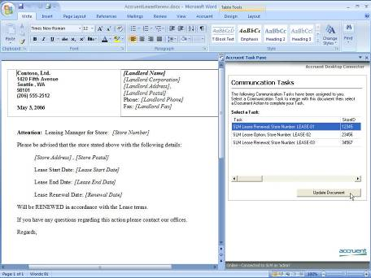
“With [Windows] Vista and the 2007 Microsoft Office system, you’re basically able to load this stuff in the background, and everything is a lot more intelligent,” says Waldeck.

The ultimate beneficiaries of the new Accruent applications will be the company’s customers who will be able to manage their real estate portfolios more effectively, increase revenue, cut costs, and achieve sustainable compliance. “When we tell our customers what we were going to do with the new version, they can hardly wait—this is something they really need,” Waldeck says.
Microsoft Visual Studio 2005
For More Information
For more information about Microsoft products and services, call the Microsoft Sales Information Center at (800) 426-9400. In Canada, call the Microsoft Canada Information Centre at (877) 568-2495. Customers who are deaf or hard-of-hearing can reach Microsoft text telephone (TTY/TDD) services at (800) 892-5234 in the United States or (905) 568-9641 in Canada. Outside the 50 United States and Canada, please contact your local Microsoft subsidiary. To access information using the World Wide Web, go to: www.microsoft.com

For more information about Accruent products and services, call (310) 526-5700 or visit the Web site at: www.accruent.com

© 2006 Microsoft Corporation. All rights reserved. This case study is for informational purposes only. MICROSOFT MAKES NO WARRANTIES, EXPRESS OR IMPLIED, IN THIS SUMMARY. Microsoft, MapPoint, SharePoint, SQL Server, Virtual Earth, Visual C#, Visual Studio, Windows, Windows Vista, and WinFX are either registered trademarks or trademarks of Microsoft Corporation in the United States and/or other countries. All other trademarks are property of their respective owners.

Document published August September 2006

Software and Services  - Microsoft Windows Vista Ultimate  - Microsoft Servers  - Microsoft Office SharePoint Portal Server 2007  - Microsoft SQL Server 2005  - 2007 Microsoft Office system  - Microsoft Visual Studio  - Microsoft Visual Studio 2005 Team Edition for Software Developers  - Microsoft MapPoint® 2006  - Technologies  - ASP.NET 2.0 “Atlas” | - Microsoft .NET Framework 3.0 with Windows Communication Foundation “Indigo,” Windows Presentation Foundation “Avalon,” and XML Paper Specification  - Microsoft Virtual Earth SDK  Partner  - Accruent

Microsoft Visual Studio 2005 is the world’s most popular development environment for designing, developing, and testing next-generation Windows®-based solutions and Web applications and services. By improving the development experience for Windows, the Web, mobile devices, and Microsoft Office, Visual Studio 2005 helps organizations deliver a variety of solutions more productively than ever before. Visual Studio Team System expands the product line with new software tools that enable greater communication and collaboration throughout the development life cycle. With Visual Studio 2005, businesses can deliver modern service-oriented solutions more efficiently.
www.msdn.microsoft.com/vstudio

Acquire Visual Studio 2005:
www.msdn.microsoft.com/vstudio/howtobuy

MSDN® Subscriptions:
www.msdn.microsoft.com/subscriptions

